***THE ENGINEERING METHOD***

**Context:**

The International Basketball Federation wants to develop a software that make the job of analysing all the data of the games easier dividing each player with its own stats per season.

**Problem developing**

In order to solve the situation, we were faced, we decided to use the engineering method to focus on a systematic view that match with the problem.

Following the steps of the engineering method from the book “introduction to engineering” from Paul Wright, we defined the next diagram which describe the steps we are going to use in the process.

**Problem identification**

Basketball has become a huge sport with thousands of fans around the world and loads of players in the court, meanwhile the game has evolved the way it’s seen has changed too and now it’s crucial to study all the statistics in order to pick the best tactics, players and game actions in each game.

Nowadays thanks to the software developing it’s easier to manage a big amount of data in cases like this one

*Sympthoms and necesities:*

* The program has to upload the players to start the searching and classification
* The players have to have specifics stats to classify them
* The program has to be able to manage players (adding, deleting. Editing)
* The program has to be able to read solid text
* The program has to be able to manage big amounts of data

*Problem definition:*

The problem requires to develop a software that let the user manage the players and their stats, letting the user classify them, modify them and work with a large amount of data

**Data recompilation**

In order to create a solution for the problem we are faced, we have to analyse the process of organizing statistics in a data base and sorting them by categories. Following next, there are the concepts we searched about to be able to solve the problem correctly

**Generics:**

[1]Generics mean parameterized types. The idea is to allow type to be a parameter to methods, classes, and interfaces. Using Generics, it is possible to create classes that work with different data types. An entity such as class, interface, or method that operates on a parameterized type is called a generic entity.

**Github:**

[2]GitHub is one of the world’s largest community of developers. It’s an intricate platform that fosters collaboration and communication between developers. GitHub has several useful features that enable development teams to work together on the same project and easily create new versions of software without disrupting the current versions

**Binary Search Trees:**

[3]An AVL tree is another balanced binary search tree. Named after their inventors, Adelson-Velskii and Landis, they were the first dynamically balanced trees to be proposed. Like red-black trees, they are not perfectly balanced, but pairs of sub-trees differ in height by at most 1, maintaining an O(logn) search time. Addition and deletion operations also take O(logn) time

**Creative ideas research**

To develop an accurate solution for the situation, we have thought and researched different alternatives. We used the brainstorming technique, a spontaneous generation of ideas designed to solve a problem. For the alternatives we followed the indication presented to get to the optimum answer.

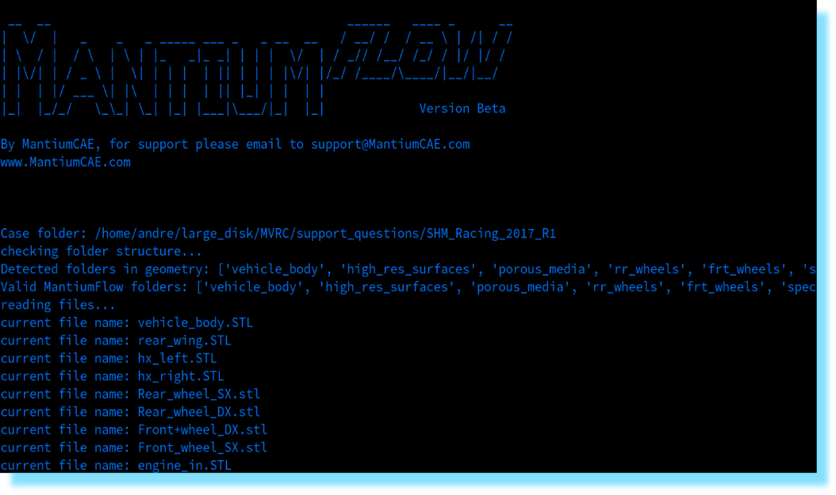*1st idea, CLI interface*

This idea consists of implementing a software in a command line interface run by the console or terminal of the device selected. It would manage the data by categories, and it would let the user manipulate the filters and search specific characteristics.

*2nd idea, GUI interface with AVL Tree*

This idea consists of implementing a software in a graphical interface like most current applications. It would manage the data by categories, and it would let the user manipulate the filters and search specific characteristics. In this case we would use AVL trees making the managing of the players more efficient because of its complexity.

*3rd Idea, GUI interface with Stacks*

This idea consists of implementing a software in a graphical interface like most current applications. It would manage the data by categories, and it would let the user manipulate the filters and search specific characteristics. Interfaz de usuario gráfica, Aplicación
In this case we would use Stacks in order to save and load the players in the program

*4th Idea, GUI interface with queues*

This idea consists of implementing a software in a graphical interface like most current applications. It would manage the data by categories, and it would let the user manipulate the filters and search specific characteristics. In this case, we would use queues to manage and load the players in the program.

*5th idea, GUI interface with linked list*

This idea consists of implementing a software in a graphical interface like most current applications. It would manage the data by categories, and it would let the user manipulate the filters and search specific characteristics. In this case we would use linked lists to manage and load the players in the program.

*6th idea, online interface*

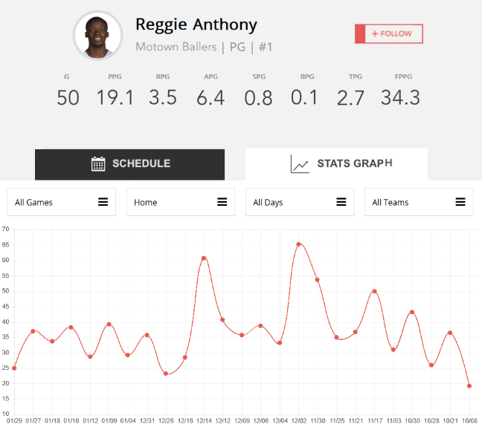This idea consists of implementing a software in an online data base with a user in a specific website, it would manage the data by categories, and it would let the user manipulate the filters and search specific characteristics in live time and constantly updating.

**Transition from idea’s formulation to predesigns**

The ideas let us analyse the situation and decide a way to proceed, by comparing the six options we narrow it down to three of them.

For the solution we reckon that the 2nd, the 3rd, and the 4th solution could be the most accurate in this case but, by analysing more deeply we decided to use the 2nd one because the AVL trees are more efficient, and its complexity is way lower that the rest.

The first solution would be harder to use, and not so attractive for the users. In the other hand, the online interface would be too advance and complicated for the step we are learning in the academic program, and the linked lists have a way to big complexity in order to make the program efficient.

**Evaluation and selection of the best solution**

Wanting to judge all the alternatives we’ve planned in order to choose the most accurate, some parameters have been chosen and enumerated in the following statements.

Parameter A:

Simulation accuracy. The program gives a:

- [2] Highly accurate simulation

- [1] Approximated simulation

-Parameter B:

User operation. The program let the customer:

- [2] Manage the program easily and clearly

- [1] Manage the program with a little complexion

-Parameter C:

Visual attractiveness. The program would:

- [2] Be more attractive for the customer to increase to shopping rate

- [1] Be plane and not so attractive for the customer

Judgment:

|  |  |  |  |  |
| --- | --- | --- | --- | --- |
|  | Parameter A | Parameter B | Parameter C | Total |
| 3st alternative | 1 | 2 | 1 | 4 |
| 2nd alternative | 2 | 2 | 2 | 6 |
| 4rd alternative | 2 | 1 | 2 | 5 |

Selecting:

After checking the judge, we can conclude that the 2nd alternative it’s the most reliable to solve the problem because, it got the highest score with the parameters.

**REPORTS AND SPECIFICATIONS**

The specification, design and require documents that the program needs to implement can be found in the docs folder of the Github repository where the project is stored.

**DESING IMPLEMENTATION**

The implementation can be founded in the Github repository. It’s made with java and javafx.

1. https://www.geeksforgeeks.org/generics-in-java/
2. https://blog.devmountain.com/what-is-github-and-how-do-you-use-it/
3. https://www.icesi.edu.co/moodle/pluginfile.php?file=%2F45665%2Fmod_resource%2Fcontent%2F1%2FArbolAVL.pdf